

GENERAL WARNING


STRONG MAGNETIC FIELD
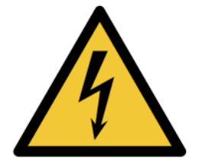
ELECTRICAL HAZARD

PLEASE DO NOT TOUCH AND KEEP YOUR DISTANCE

IN CASE OF AN EMERGENCY PLEASE CONTACT LENA MATOTA

CELL. NO: 071 569 2349
EMAIL: 24989142@sun.ac.za

